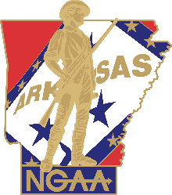

2020 NGAA Individual Award Nomination Form
Point of Contact: Lt Col Paul Needham, paul.j.needham.mil@mail.mil

Nomination Deadline: 15 March 2020
Award Nominated to Receive:
Nominated by:
Name/Rank/Duty/Title/Organization or Unit of Assignment of Nominee:

Years in the National Guard:
Justification for Award:

Proposed Citation:

